**Boy-Focused Teaching**

**A Desktop Reference**

**for the faculty of Blue Ridge School**

The purpose of this desktop reference is to provide the teachers of Blue Ridge School with a tool to help them maximize their pedagogical efforts with the School’s boys.

**Essential Premises to the School’s Work with Boys**

We believe the research that cites the merits of single gender education.

We understand that taking advantage of the merits of single gender education requires an understanding of how to effectively teach boys.

We know that to be an effective teacher of boys, one does not have to be a neuroscientist.

We understand that just as there are differences between girls and boys, there are also differences among boys.  Furthermore, we understand that even the same boy can demonstrate varied behaviors on different days and settings.

We appreciate that many differences between boys and girls erode by adulthood.  The issue is not about superiority or inferiority.  The issue is about developmental differences.   Blue Ridge teachers are focused on those differences as they work with adolescent boys.

We will continue to espouse our BRS Learning Model principles of “backward planning” and “enduring understandings.”

We believe that above all else in importance is building meaningful relationships with our boys.

**Relative Strengths of Boys**

Boys are capable of detecting and then analyzing motion.  They are more adept at confronting stress.

Boys are also more adept at performing tasks requiring spatial acumen or gross motor acumen.

**Relative Challenges for Boys**

Boys are more likely to act on impulse rather than reason.  They are not as good at multi-tasking.

Boys are not able to make subtle distinctions in sound and are not as capable of performing tasks requiring fine motor skills.  They are also not as adept at interpreting nonverbal clues.  Boys are prone to becoming unfocused due to their brains entering biological “rest states.”  They are also not as capable of performing tasks requiring verbal acumen.

**Advantages of Our All-Boys Environment**

Our faculty can focus on becoming experts on boys.

Every aspect of our total program can be “boy focused.”

Our boys can feel safe in stepping outside gender stereotypes and personal comfort zones.

There are more bonding opportunities within the student body.

The distractions created in a coeducational environment are removed.

Boys are more comfortable taking intellectual risks.

The desire to “show off” is greatly reduced.

Our boys are better able to direct a higher percentage of their energy toward tasks critical to achieving success in the most vital aspects of school.

**Lesson Plans that Work with Boys**

Lessons that produce products (e.g. foreign language travel brochures)

Lessons that are structured as games (e.g. vocabulary building puzzles)

Lessons that contain vigorous motor activity (e.g. utilization of the campus)

Lessons that ask boys to assist the learning of their peers (e.g. writing peer reviews)

Lessons that are presented as  problems to be solved (e.g. Physics “egjg drop”)

Lessons that stress teamwork (e.g. challenge course)

Lessons that stress competition between teams (e.g. group centered projects with a reward system)

Lessons that contain elements leading to self-discovery (e.g. relating characters, known people to self)

Lessons that use visuals (e.g. writing assignments prompted by pictures)

Lessons that use role playing (e.g. using prominent historical figures)

Lessons that are “hands on” (e.g. building rockets)

Lessons that are presented as experiments (e.g. math assignments that “discover” theorems)

Lessons containing novelties and surprises (e.g. dressing in costume)

**Techniques of Teaching that Work with Boys**

Making Points Through Transitivity (“If you like baseball, then you’ll enjoy the study of quadratic equations.”)

Providing Choices for the Boys

Using “Codes” that Signify key Concepts or Key Expectations

Allowing for the Use of Deductive Reasoning

Providing  Evidence When Presenting Concepts

Repeating/Reinforcing to Minimize the  Impact of Rest States

Providing Alternative Assessments

**Techniques of Classroom Management that Work with Boys**

Providing the Boys with an Opportunity for Input into Classroom Rules

Allowing Time for the Boys to Formulate Responses

Treating the Boys like Adults (even when they are not acting like adults)

Talking “Shoulder to Shoulder” with a boy (as opposed to “face-to-face”)

Praising the Boys in Public, Correcting the Boys in Private

**When teaching boys…**

Start with an attention-getting question or activity

   Boys retain more at a slightly heightened state of mental arousal.

Talk louder

   Boys, and males of all ages, have less sensitive hearing.

Repeat important information a couple of times

   Boys often “cycle in” and “cycle out” of attention within short time spans.

Explain the “big picture” at the beginning and link back to it at the end

   Boys often perform better if they know where the lesson is going beforehand.

Do one task at a time

   Multi-tasking is a myth for everyone, but especially for boys.

Use short “chunks” of verbal (oral or written) material and provide time for the boys to process the material and tell you what they get from it; consider using a verbal “warm-up” activity first

   Boys process information and then talk about it; they don’t often process and talk simultaneously.  Verbal skills in general may lag behind those of girls.

Use a visual handout that demands the boys’ motor/tactile engagement

   Static visual images are less effective than charts/graphs/diagrams that the boys must sketch or complete for themselves

If it can be drawn, traced, or physically acted out, do so

   Boys use their visual-spatial skills and propensity for motion to learn better.

Cycle back to check for understanding every 20 minutes or so

   Good practice for all, but quite necessary for boys (see above re: “cycling in/out”)

Use positive competition for review where applicable

   Boys are generally more engaged when competing, including against themselves and as part of a team.

Plan for impulsivity

   Boys will more often act first, think second, and rationalize later. Recognizing this tendency and using the teachable moments that arise from this behavior, keeps the class environment more positive.

Maintain a strong and positive relationship with the students

   Again, boys are more forcefully ruled by their emotions in their relationships with teachers.  Like most of us, they will learn less from a teacher whom they dislike or who they feel dislikes them.

We must remember that boys are “relational learners.”  They develop much more when working with adults with whom they sense a real bond.

**Boys BUILD RELATIONSHIPS with adults who demonstrate:**

An even temperament, even to the point of “light-heartedness.”

A good sense of humor.

Fairness and consistency…and forgiveness.

Patience.

The importance of establishing and maintaining boundaries.

Belief in them, to include the establishment of lofty goals.

The ability to adjust.

A work that mirrors a commitment to their growth,

**Working with Boys Who Are Struggling**

Not all of our boys “get it” upon arrival in St. George.  Some do not “get it” even after considerable time with us.  In such cases, we are not serving them well by simply “trying the same tactic again.”  When working with boys who are struggling, postpone your efforts to attain the usual objectives (e.g. content mastery) and focus upon these five “Rs.”

How can I replace the boy’s attitude?  Spend some time with him without an agenda…perhaps off campus.

How can I get the boy to reconnect to the school?   Help the boy to understand the extent to which the school shares the same goals as he does…for not himself.

How can I help rebuild the boy’s life and learning skills?  Help him to understand what skills he needs to be successful and how he can attain them...with your help.

How can I reduce the boy’s need to act out?  Help the boy to understand how problems are solved…and how they are intensified.

Do not repeat your unsuccessful tactic.

Do reinvent the boy.

**Excerpts from “Listen Up, Teacher! You are making a difference”**

**Shirley Garcia and David Cottrell     CornerStone Leadership Institute, 2002**

**Ten Things Our Boys Want to Tell Us**

We need you to expect more from us than we do from ourselves.

Whatever the case, hold fast to your dream of what we can become.  Remember, some of us will whine and pout along the way, but if you hold us to high expectations… You will be the teacher we remember as the one who truly made a positive impact in our lives.  What an awesome legacy!  Be relentless with high expectations!

…you will have to get to know us personally.  Not just a name in a roll book or a student in third period, or the one who turns in homework late, but the essence of who we are and how you can best reach us.

You are our role model and what you do in your classroom reaches far beyond the classroom.  We are watching, so be fair, use good judgment, and don’t forget that we are learning from you.

If we didn’t get it the first time you taught it, we probably won’t the second time around unless you teach it differently.

Here is a tip:  One sure way for us to understand what you are teaching is to make it relevant to our lives…outside the school setting, on the playing field, at our part-time job or in our relationships.

Hanging in there and not giving up on us when some of us have given up on ourselves is what we need from you.  Maybe it was your insistence that we follow the rules that taught us how to become better citizens and consequently, better people.  Maybe it was your encouragement when no one else seemed to think we could ever get it right.

Everything you do teaches a lesson, even away from the classroom.  We watch your actions and we hear your words and we are influenced positively or negatively.  Guard your integrity like your most prized possession.  It is.

We know that sometimes you get so busy that you may forget to praise us when we’ve earned it.  All of us – and especially teachers – need to be recognized and praised for the work they do and the effort they expend.  Of course, praise must be genuine because we can sense when it’s not.

A final thought.  When you became a teacher, you chose one of the greatest and most important professions on the planet … more important than rocket science, greater than running a corporation, more noble than the Peace Corps or military service.  And, you made a good choice.  You now have the spectacular privilege of spending time with children and young people who are eager to learn (okay, most of them).  Oh yes! The pay could be better.  The stress could be less.  Your feet would feel better if you could sit down more often.  Parents could be kinder.  Administrators could be more innovative … and, of course, kids could behave better and work harder.  But, when all is said and done, success in life is judged by the lives you touch.  There is no test or scorecard to measure your impact on our lives.  You do make a difference, even in ways that you cannot imagine.

**The “Why”  and “How” of Understanding by Design**

While cherishing the concept of academic freedom for its faculty, BRS also appreciates the need for a learning theme that crosses all disciplines.  Understanding by Design gives us a guide for our curricular efforts on both  macro and micro levels.  UbD serves a template for how we design our courses and our units within those courses.

1. Its emphasis on the “big picture”
2. Its emphasis on beginning with the end in mind
3. Its emphasis on enduring understandings
4. Its adherence to the research on how students learn best
5. Its focus on uncoverage rather than coverage
6. Its advocacy of creative and real world related assessments to measure  understanding
7. Its emphasis on planning courses before planning units and planning units before planning lessons
8. Think like an architect:  What do I want the building to look like and how do I want it to function?
9. Develop a list of desired course outcomes for the students.
10. Develop essential questions whose answers indicated achievement of these desired outcomes.  These questions are “big picture oriented” and likely will not have a single “correct answer.”
11. Make the students aware of the importance of these outcomes and the associated questions.
12. Continue to focus on these questions throughout the year.  Reference them from “unit to unit.”
13. Design each unit of the course using the following methodology:
14. Identify the desired results.
15. What essential questions will be considered specific to this unit?
16. What understandings are desired?
17. What skills must be mastered to achieve these understandings?
18. Determine acceptable evidence that the students have achieved the desired understandings.
19. What student tasks would best demonstrate understanding?
20. By what criteria will these tasks be evaluated?
21. Plan learning experiences designed to achieve the desired understandings.
22. What sequences of teaching and learning experiences will equip students to engage with,
23. Develop, and demonstrate the desired understandings?

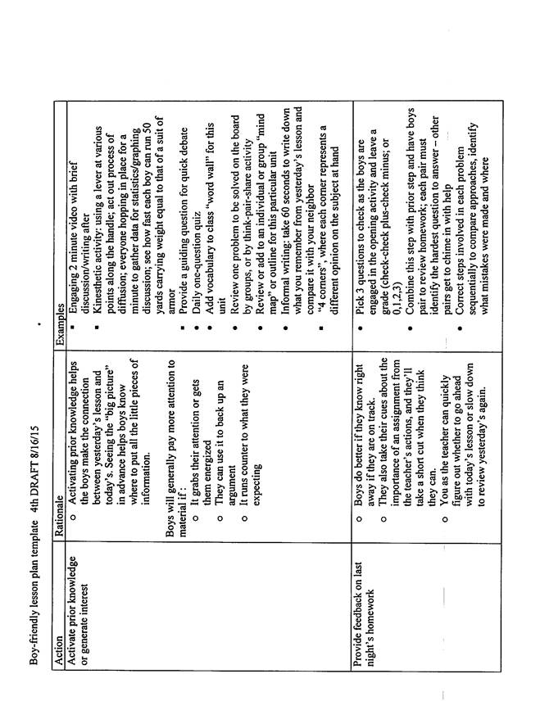

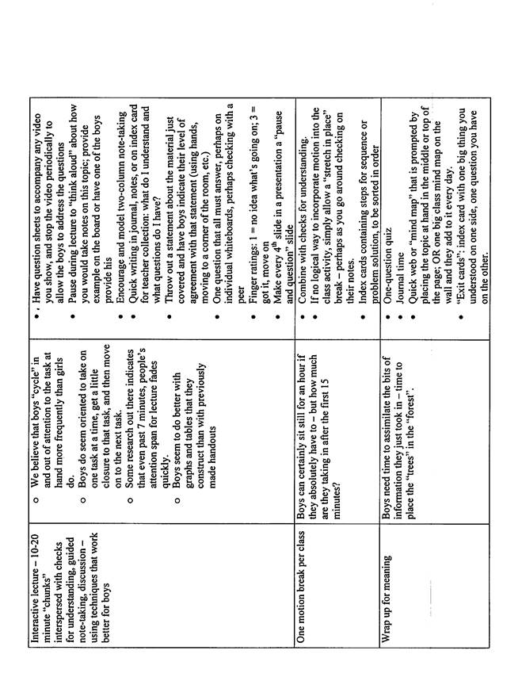

**Jon Baker**

**Lessons embracing Teaching Boys Methodology**

1. Lessons that ask boys to assist the learning of their peers (e.g. writing peer reviews)

I had each of my students present a webpage that they found useful for research.  Before the presentation I gave the students a rubric which provided a scoring system for four areas of the presentation –usefulness of material, quality of presentation, preparation and was the information presented in an interesting manner. The students graded each other using the rubric and everyone did both a better job of presenting and paid closer attention, since they had to give a grade. I used the student assigned grades for this project, as they were all fair and thoughtful.

Lessons that contain elements leading to self-discovery (e.g. relating characters, known people to self)

In our discussions of Feed by M.T. Anderson I ask the boys to strip away the science fiction aspects of the story and see the characters (high school students) as their peers. The characters are young people dealing with the stresses of a changing world, the crush of materialism and a friend’s death. When I ask the boys to put the characters experiences into the context of their own lives the discussions have been really amazing, with everyone in the class vying to share or refute opinions.

Lessons that contain vigorous motor activitiy (e.g. utilization of the campus)

In my lesson planning (which starts with a set of college level information literacy competencies approved by the American Library Association and backward maps to activities that help students discover and practice these skills) I created two information hunts in the library. One is a text-based hunt involving all types of books in the library, fiction, nonfiction and an array of reference books like dictionaries, almanacs, encyclopedias, annotated bibliographies, timelines of history, etc. The other is a digital hunt involving our databases and e-books as well as outside resources including some digital archives from the Library of Congress and Oxford University. The text based hunt especially has students moving around the library as they gather books that contain the answers to a list of questions about history, science, literature, and other cultures.

**A former language teacher**

Lesson Plans that work with boys, 10 – Lessons that use role playing

I use dialogs to teach Spanish conversation skills in a variety of real-life situations. For example, the boys play the role of a customer or waiter in a restaurant, first reading the dialog to each other, then memorizing it and playing the roles as written, and finally adding to it as they become more secure with the basic vocabulary and grammar. Similar dialogs are used for hotel and plane reservations, asking directions, buying clothes and going to the bank. These dialogs give the boys a skill they can use (and have used) immediately in a Mexican restaurant or when travelling in a Spanish-speaking country.

**Peter Bonds**

In my history class I have had particular success in teaching boys by incorporating elements of product-based learning, collaboration, and role-playing into my lessons. Currently, my students are working on a project that involves each of these techniques. In studying the Age of Enlightenment in Europe I have assigned each student to assume the role of a major historical figure associated with the Enlightenment. After conducting some preliminary research on his figure, each student set up a Twitter account in the name and identity of that figure. Over the course of two weeks I have been assigning topics about which each student must tweet. These assignments require them to research the Age of Enlightenment and allow them to demonstrate their knowledge in a witty and fun manner. The students are also required to follow all of their classmates on twitter and tweet questions to their classmates which then must be answered. I keep track and grade them on the quantity and the quality of their activity. It has been fun as a teacher to see tweets go up at all hours of the day and night from students who normally at that time of day would not be thinking about European History.

In my freshman English class I recently had success with a product based lesson in which my goal was to teach students how to make their writing more interesting and appealing to their readers, and how to write concisely. After spending a day looking at newspapers and the style in which the articles are written, each student was assigned to write an article or an op-ed piece about a news story here at Blue Ridge. After picking their stories and going out and interviewing various people to get quotes for their stories, the students compiled their articles into the “Blue Ridge Times” which was distributed to the entire school community. They really enjoyed, and were motivated, by the fact that other people besides me would be reading and commenting on the work that they had done.

**Vinton Bruton**

1. In Early American Studies (Junior Humanities) and in the Civil War Elective I taught last year, I present decision-games to the students to draw them into a key moment in history. For example, during a lesson on Gettysburg, I present a scenario in which the boys assume the role of Colonel Joshua Chamberlain, commanding officer of the 20th Maine Regiment, which successfully defended Little Round Top on July 2nd, 1863. I briefly present the scenario and give them several options on how they might choose to defend the position. The boys make a decision and explain their decision to their classmates. I then explain what Chamberlain actually did. (Teaching Boys: A Desktop Reference Page 5: #5)

2. When I lecture, I always provide a visual support so that visual learners have something to "hold on to." I usually use PowerPoint to show pictures of important people, maps, charts or graphs, and quotes so that those who are not audio-learners are not left out. (Teaching Boys: A Desktop Reference Page 5: #9)

3. I invite Civil War re-enactors (usually Bill Graham for the Confederacy and recently Mike Dehrenbacher for the Union) to campus to teach about the life of Civil War soldiers to my junior history students. The boys get to load and fire black powder charges from a rifled-musket, march in formations, and try on uniforms. Once I staged a Civil War camp-out in which the boys cooked and ate a meal commonly eaten by soldiers, then spent in the night in the cabin at Cabin Lake. (Teaching Boys: A Desktop Reference Page 5: #3, #10, #11, #12, #13)

4. During my Civil War elective, I gave the students a brief lesson on John Brown, then gave them a map of the town of Harpers Ferry and had the students work in teams to plan John Brown's Raid on the town. They then presented their plans to their classmates. Later that year we took a field trip to Harpers Ferry, so the boys could see how well their plans would have worked, comparing their plans to John Brown's failed raid. (Teaching Boys: A Desktop Reference Page 5, #1, #5, #10, #12)

**Brandon Deane**

In the Topics in Physics class the students were asked to design a wind chime

Determine the notes which you want the chimes to produce.

Calculate the frequency of those notes and the length a chime should be to produce the desired note.

Cut and fine tune the chimes.

Design and construct the complete apparatus to take advantage of the location of the nodes and antinodes on each chime to maximize the responsiveness of the devise.

How do I motivate my students to learn together-

Test corrections are “open resource study” so kids are motivated to ask others for help.

When preparing to correct your test you can use any resource to learn the information; notes, book, internet, other students, faculty.

When composing your final response follow the same rules as you do on a test in class, do not refer directly to any notes or those sources, work out  of your head.

I actually love it when a couple of students miss a lab and need to make it up.

I identify the students who need to make up the lab to everyone.

I make it worth their while (extra credit) to be an expert and help facilitate the make-up effort which includes teaching the concepts and analysis well enough for the other student to complete their lab report.

Obviously teams work this way when working through a lab together.

**From  a Prior Math Teacher**

Curve the Test. Allowing boys a voice in classroom management works well with boys. Early in the semester I presented the boys with the results of a recent test. Without showing them their individual grades, I showed them the raw scores and what the test results would look like if I graded using the traditional model. I then reviewed with them four different ways to “curve” test grades. I then allowed them to break into small groups and settle on a proposal for the “fairest” system of curving. They had to show how their system would affect, high-scoring students, low-scoring students, and an average-scoring student.  I took each group’s suggestions and chose the final method based on their selections. Not only did the boys get a voice in how I curved the test, they did a bit of math (calculating means, medians, modes, and percentiles, etc.) along the way.

**Jerry Jared**

Examples of using “Teaching Boys” best practices in the classroom.

1.       In Calculus when studying related rates we used a BB gun to estimate the effect of the low power of the gun on how far the BB would go when shot out of the gun.  At the end of the lesson we all got a chance to shoot the gun at a target to see how accurate we could be.

2.       In Discrete Math each student got a chance to build a Conway Pencil Ball out of rubber bands and pencils.  The relationship between the ball and the hypercube was discussed.

**From a Prior Music Teacher**

In the classroom:

Started both music classes with a unit on rhythm/percussion.  It proved to be an easy access point for nearly every boy; very hands-on (literally) and physically active; a whole-group activity that nevertheless provided a place for individual contribution; very cross-cultural, as many, many societies have a rich percussion tradition; and an element of “subversive danger” in staging a lunchtime percussion flashmob.

Kept music theory applied immediately to learning songs on the keyboard; i.e., tied “immediate gratification” to more abstract theoretical content.

In Introduction to Theater, we started with bodies/movement rather than words from a script (physical over verbal), then moved to noise-making, then one single word per scene, then short dialogues, and finally full dialogue scenes.  I selected scenes for men, no surprise, but tried to help them explore what kind of man they were portraying, sharpening their skills of inter-personal observation.

Provided both keyboard and theater students an informal performance venue at trimester’s end.

Beyond the classroom:

Found that one student aspired to be some kind of designer, but has done very little drawing.  So I gave him a sketchbook and assigned him to draw a page a day.  Since then, he has regularly turned in his work to me for critique / comment.

Followed up on a comment one student made at an FCA meeting, which turned into a good, long walk/talk.  He tells a lot of stories from his very non-traditional life, so I gave him a blank book and told him to write down his memory stories as they come to mind.  He has begun to do so and give me back the journal to read/respond.  Again, he now knows that he is known.

**Marcia Kozloski**

There is one project in particular that I favor because the students work on a puppet show. They write the script in the target language, create puppets using different materials, and they do a puppet show. It teaches them to work with a partner, to use creativity, and practice the language. This type of activity gives the students a choice and a way for them to express themselves.

In class we practice going to a barber, hairdresser, a bank, a post office, a dry cleaners, etc, and they have to act out with a partner. It gives the students an opportunity to work with real situations and practice the target language. This activity promotes role play.

The activities above provide alternative assessments.

**From a Prior International Student Coordinator**

Lessons That  Challenge Preconceptions: In the world cultures class, I've often shown short video clips, or newspaper articles, or advertisements to make a point to the students. For example, when the students were learning about race, I asked them to complete a PBS activity where they were to sort people into different racial groups. When the students realized it was a lot harder than they expected, their perceptions were challenged and they wanted to learn more about how people are categorized by society and how that can affect someone's life. I also showed them a short clip of racism in Disney movies and we discussed how certain characters are portrayed and why they are portrayed that way.

Lessons Presented As Experiments: I find that lessons work the best when the students "discover" the meaning on their own. For one class activity, the students went outside and did an activity in which I asked them to move back and forth in response to statements that I read out loud. I did not explicitly say what the lesson was about beforehand and at the end asked the students to take note of where they were standing. When we came inside the classroom, they were able to figure out what how privilege works and how those who are not afforded certain privileges can be at a disadvantage.

Lessons that Contain Elements Leading to Self-Discovery: As I mentioned above, I prefer when students learn on their own and I take on a more facilitative role. Because the class material is so new to the students, every lesson in the world cultures class is meant to be enlightening and lead to self-discovery. I think it is important not only for me to challenge the students, but that they challenge themselves as well. One of my favorite moments was when the students read an essay about the "Nacirema". The essay is written as if it is an anthropological study of a strange group of people who live somewhere between Canada and Mexico. In the end, and after much discussion, the students discovered that the essay was really a criticism of American society. I think they were surprised at how strange American culture could seem through the eyes of an outsider and they began to question their own place in American society.

**Kevin Miller**

Opening up work on writing skills with timed word list brainstorms (free-association pairs, "name all the things you can think of that are ______", etc).  Boys often need time to "warm up" their language centers and the atmosphere of low-key competition usually helps focus their attention.

Having the boys make journal entries on various topics - some academic, some personal, some on whatever topic they choose.  I did this once or twice before when I was teaching 9th grade science and was struck by the degree to which such a small task could help the boys open up a little and build a relationship with me.  Within these journals I find complaints about roommates, concerns about home, and (sometimes) thoughtful analyses of how they might handle a problem situation.

Teaching basic algebra skills using a visual of a balance scale, and sometimes the real thing.  Boys often "get" visual patterns faster than verbal patterns, so they pick up more quickly on both the principle of balance (what you do to one side of the equation you must also do to the other side) and the concept of combining like terms (don't try to combine the "boxes" (variables) with the "coins" (integers)).

**Bryan Puckett**

In my classroom I will take class periods to have the boys do physical activity in order to produce some data or reference point for an upcoming lesson. For instance, I took my Algebra classes to the gym for all of them to shoot a different number of free throws so we could use percents and decimals to compare the results.  (#3 Lessons that contain vigorous motor activity)

In my classroom I have made lessons in which the students have to work together. For instance, I had students work together to find objects and places on campus that have Geometric shapes that help define certain vocabulary words. The boys had to find these objects, take pictures, and label. (#6 Lessons that stress teamwork)

**Krystle Roach**

Lessons that stress competitions between teams

In my classroom, we have LOTS of competitions to help with review. The games include: jeopardy, INTELIGENTE (where the first group that becomes intelligent wins), the ladder game (where a board starts with the first person of the ladder and works its way to the back, adding more information along the way), among other activities. The boys get really involved in these games. You can definitely see the seriousness click in when I say it’s game time! I love seeing their energy because it shows that they do understand the information (and might even like it a little). Finally, we have a reward system in my classroom. The first week of school the boys received a “reward sheet” that has multiple prizes. In order to win a prize, you have to win a certain amount of stickers. The rewards are: free homework pass, free journal pass, a bag of your favorite candy, three answers on a test, and five extra points. It is amazing how many student take advantage of the academic rewards versus the candy! This system really seems to work. Every time I say that we are going to play a game, it never fails that a student will ask “Is it for a sticker”. I am sure that if someone walked in at that exact moment, they may wonder just why a group of HIGH SCHOOL BOYS are asking for a sticker.

Lessons that use visuals.

In my classroom, we use journals at least once a week as a reflection of what we have learned. Each journal has three pieces to it: writing, drawing, and questions. They are given a specific topic sometimes it is something that I ask and sometimes it is a picture. After they finish the writing portion on the prompt given they are then asked to draw something that pulls it all together. Some of the boys find this the hardest part but once I give them clues then they are able to follow through. By visually tying the written information together they are more likely to understand and use the information. There are times when I can see the boys picking out things they may have drew when they are taking a test. By using a journal that has so many different concepts to it I am also able to appeal to many learning types as well: the writer, the artist and the questioner.

**Cory Woods**

In regard to “Relative Strengths of Boys”…

I structure the Outdoor Living Skills curriculum to focus on backcountry travel skills in a way that strives to keep students active with a series of hands-on projects that involve physical manipulation.  Students fashion camp stoves out of coke cans, practice campsite cooking skills, participate in trail (re)designs, teach their peers a new skill in collective knot-tying instruction, complete an orienteering course after map and compass instruction, and have even improvised shelters out of snow and debris for overnight stays.  These exercises reinforce wilderness survival and backcountry travel skills, while building on the strengths of “spatial/gross motor acumen”.

In regard to “Lesson Plans That Work With Boys”…

I structure the Outdoor Leadership curriculum to focus on the group development process; helping each boy experience this by charging him to lead his peers in a selection of team-building initiatives.  These exercises provide the students with an opportunity to learn in a “game” atmosphere and from each other, practice problem-solving, work as a team, participate in a friendly competition, and produce products (the activities or lesson-plan for their assigned days).  Students inevitably learn more about themselves as they learn principles of leadership and cooperation.  This structure gets the class outside the “normal” learning environment and helps to maintain physical activity.

**John Young**

Lesson Plans that work with boys: Lessons that use visuals :

I have developed a set of PowerPoint presentations for each of my units of study in the American Studies sections I teach that include visuals that are projected onto the whiteboard in the front of my classroom. Using a handheld remote control, I can click to bring up a visual related to the topic under discussion. These visuals can be programmed into the computer to appear in sequence with the mere push of the button on the remote control device. I can control the pace and order of the displays so as to fit the lecture/discussion. For example, was I to be talking about or engaging in a discussion with the boys about one of the topics below, the following would happen…

the bombing of Pearl Harbor – I have collected about twenty dramatic photographs taken by servicemen and civilian newspaper photographers at the time the attack was underway, YouTube videos featuring live action film footage of the attack and the explosion of stricken ships, and dramatic recreations of the action, such as is found in films like Pearl Harbor produced by Jerry Bruckheimer that came out several years ago. In addition, I have downloaded from Google historical maps revealing the positioning of the Japanese aircraft carriers northwest of Hawaii, the route of the attack planes, the positioning of U.S. ships at anchor in the harbor, and the paths of attack that the Japanese planes took as they swept down upon the American warships. These have been woven into a montage that is displayed on the front wall of my classroom as I am describing the strategy of the Japanese attack and its devastating consequences. The impact of these images reinforces and enhances the boys’ understanding of the lecture/discussion.

Lesson Plans that work with boys: “One way for boys to understand what you are teaching is to make it relevant to their lives…outside of the school setting…”

During the course of teaching American Studies, I often run into the challenge of explaining complex economic practices to the boys. These concepts are beyond their personal experience and, therefore, difficult for them to grasp. An example of this kind of situation can be represented by trying to explain how the Federal Reserve Act passed during the first term of President Woodrow Wilson actually worked. I lay out a chart that graphically depicts the three levels of the system.

Federal Reserve Board

(based in Washington – its members appointed by the President;

Board sets the interest rate at which member banks can borrow money

from the District Bank; determines how much money will be in circulation)

12 District Banks

(member banks deposit 6% of their capital in their District Bank;

member banks can borrow needed money from the District Bank in order to make loans)

Regional Member Banks

(the Member Banks are the local banks from which people living in the community borrow money)

Individual Borrower

(A man or woman who wants to borrow money from a neighborhood

bank in order to purchase a home, automobile, take a vacation, or any other large purchase)

After discussing the chart and how in the larger sense the Federal Reserve System works, I assign the class members different roles. Some are appointees to the Federal Reserve Board, others are directors of the District Banks, some are loan officers at the Regional Member Banks, and some are young men in their mid-twenties who want to secure a loan in order to purchase their first personal car.

I then give the members of the Federal Reserve Board in Washington a set of economic circumstances that requires them to decide whether to raise or lower the rate charged to Regional Banks. The members of the Regional Banks are informed as to the reliability of the individual District Banks in their district, and they then determine whether to loan money to some and not others. The members of the District Banks are informed about the financial profile of the individual coming to take out a loan. We role play out the system by which the various decisions are made as the money makes its way down the several layers of the system. The importance of how the system operates as well as maintaining a responsible financial record is emphasized in real world terms.